Reading the Illegible: Can Law Understand Graffiti?
Katya Assaf-Zakharov & Tim Schnetgöke*
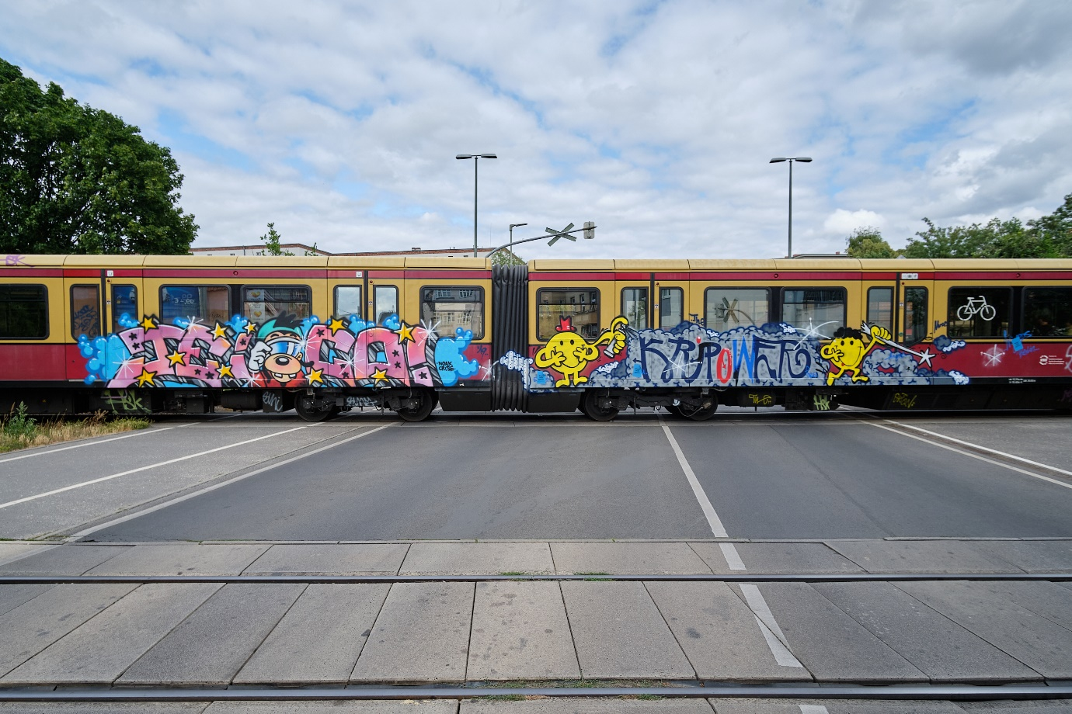

The true vocation of art is to serve as an open means of expression, communication and empowerment, focus on a wide audience, and not only on high-brow connoisseurs and frequent visitors to galleries and museums. Every day on the facade of the Atrium, thousands of people see works of art whose images and slogans make you think — this is the real role of art.
Shepard Fairey

Introduction
This essay focuses on graffiti – the practice of illegal writing and painting on trains, walls, bridges, and other publicly visual surfaces. Although the practice of uncommissioned painting of images on walls dates back to the dawn of civilization, graffiti in its current form is a distinct social and artistic phenomenon that started in New York and Philadelphia in the 1960s, has grown into an international movement, and is constantly expanding, despite substantial efforts to fight it on the part of the authorities.
Scholars from a variety of disciplines have studied graffiti, revealing the diverse social and economic backgrounds of the painters, their various motivations, and the different forms graffiti paintings take. Despite this diversity, several scholars suggested that all graffiti communicates a common message. This message reveals and challenges the hegemonic power of property, commerce, and politics that dominate our visual environment. In addition, graffiti opposes the isolation of art from everyday life and rejects the authority of art institutions to define what “real” art is.
Social responses to graffiti are highly ambivalent. On the one hand, media often picture graffitists as “vandals” and “hooligans.” Local authorities define graffiti as an “epidemic” and declare “wars on graffiti.” On the other hand, graffiti is recognized as a valuable form of art, exhibited in mainstream museums sold for high prices. Thus, a highly regarded national museum may be exhibiting works by a graffitist who is serving time in prison for his involvement in graffiti. An illegal work of one graffiti artist may be protected from being painted over by others, and even restored by authorities should it be “vandalized.” While some graffiti works are recognized as cultural heritage, others are promptly whitewashed and their creators prosecuted.
Reflecting the ambivalent social attitude, the legal treatment of graffiti is highly uneven, punishing some graffitists for vandalism while granting copyright protection to others. Courts dealing with graffitists’ copyright claims rely heavily on factors such as commercial value of the works and recognition of the artist by mainstream art institutions. They clearly favor artists that deviate from the core graffiti culture by signing their works with their real names or protecting them from being painted over by other graffitists. This creates a kind of a “dialogue of the deaf” between legal systems and typical graffitists – anonymous artists experimenting with new styles, working outside the mainstream art canons purely for the sake of creativity without expectation that their work will be preserved or bring them money and public recognition.
Scholars have made various suggestions regarding the legal regulation of graffiti, ranging from toughening the criminal sanctions to providing more legalized spaces and art programs for the painters. Yet to date, no attempt has been undertaken to understand the dissenting message of graffiti and to consider an adequate legal response to this message. As Jean Baudrillard suggested, the subtle message of graffiti “must be heard and understood.” Doing this, in the legal sphere, is the central goal of this essay. Instead of suppressing or manipulating graffiti, we propose to answer its message with redefining the boundaries of physical property so as to restrict owners’ control over surfaces that shape our urban landscape. These surfaces will then be used as a medium of free visual expression, creating a public “forum” in its classical sense: a place of discussion, opinion exchange, and purely aesthetic expression.
This essay proceeds as follows: Part I briefly introduces the reader to the culture of graffiti and delineates the common message running through the different graffiti practices; Part II outlines the highly ambivalent social and legal treatment of graffiti; focusing on the US and German legal systems, Part III describes the inadequate treatment of graffiti under copyright law; Part IV puts the ambivalence around graffiti into its larger cultural context of non-profitable creativity; Part V summarizes the main proposals on the legal regulation of graffiti; Part VI suggests an alternative perspective on graffiti regulation; Part VII proposes to redefine the borderline between property and the public space so that urban surfaces fall under the latter category; Part VIII addresses the possible objections to this proposal; and Part IX concludes the discussion and outlines directions for further research.

I. Graffiti and Its Message
The practice of uncommissioned painting of images on walls dates back to the dawn of civilization. Yet, graffiti – paintings and writings made on building exteriors, bridges, advertising billboards, trains and other publicly visible surfaces, without permission of the property owners – is a distinct social and artistic movement that emerged in Philadelphia and New York after the repression of urban race riots of the 1960s. Despite fierce efforts of urban and criminal authorities to fight graffiti, it has grown into an international movement, leaving its marks across the globe and showing no signs of decline.
The phenomenon of people painting at the risk of severe sanctions and with no prospect of economic gain has naturally sparked much scholarly interest. Research has shown that graffiti has developed into a subculture with inner rules of conduct, its own aesthetic aspirations and distinct styles. Graffiti painters tend to approach their work seriously, devoting to it much of their energy, time, and money (for paint, and sometimes also fines and civil damages). Graffitists are a very diverse group, including persons of different ages and from various economic, social, and professional backgrounds (Snyder 2016, 206). They are driven by numerous motivations, such as exercising their artistic skills, experiencing creative freedom, enjoying the thrill of risk, marking their presence, gaining recognition within the graffiti community, expressing themselves, awakening public consciousness on a social issue, making art accessible for everyone, and beautifying their city. Graffiti itself can take many forms, ranging from small “tags” – stylized signatures of graffitists’ chosen names (Fig. 1); to “throw ups” – larger names, often multicolored, sometimes incorporating characters (Fig. 2); “slogans” (Fig. 3); and “pieces” – detailed multicolored pictures (Fig. 4). The latter tend to vary in size and may occasionally be as large as to be observable from a satellite.

Figure 1 – A Tag by 10 Foot, Paris, France.
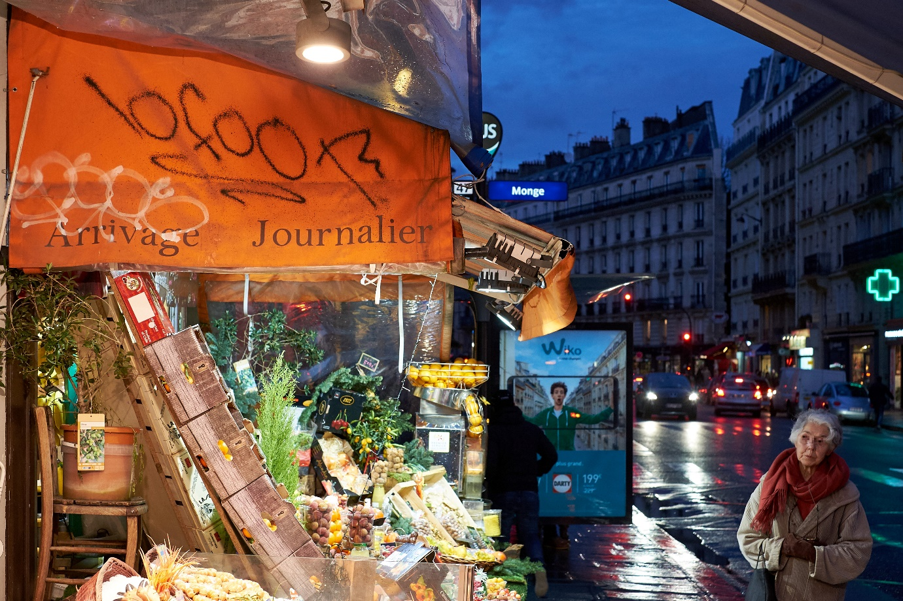

Figure 2 – A Throw Up by Revok, Naples, Italy.
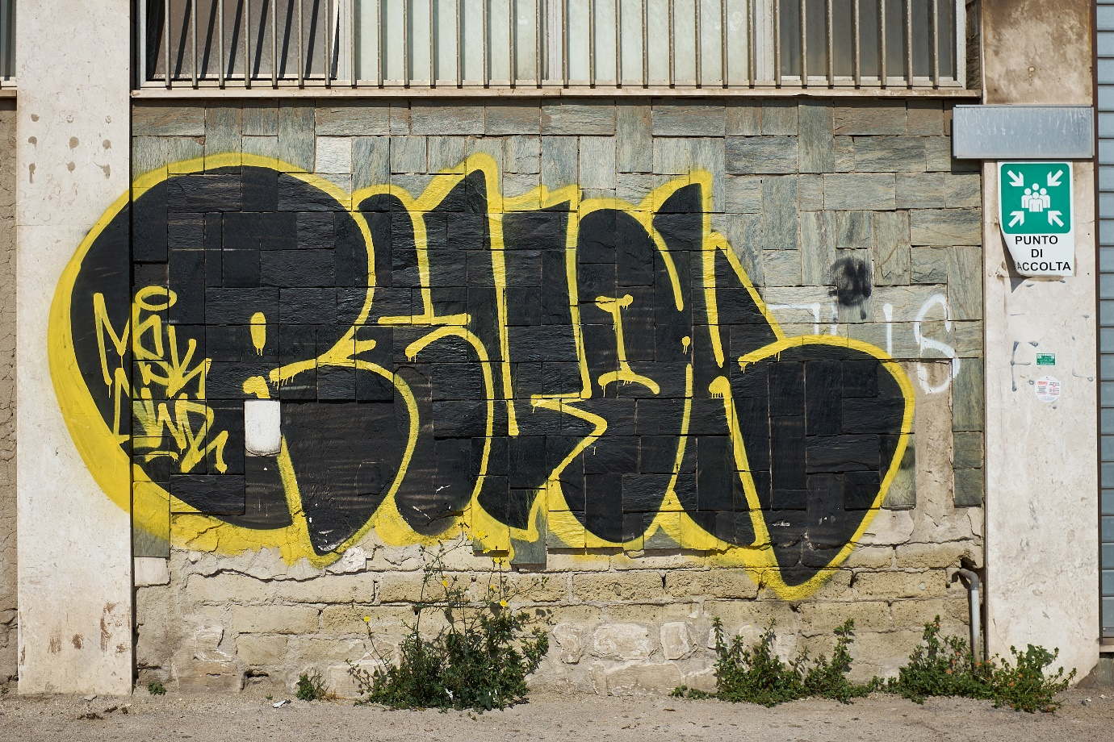
Figure 3 – Slogans in Berlin, Germany.
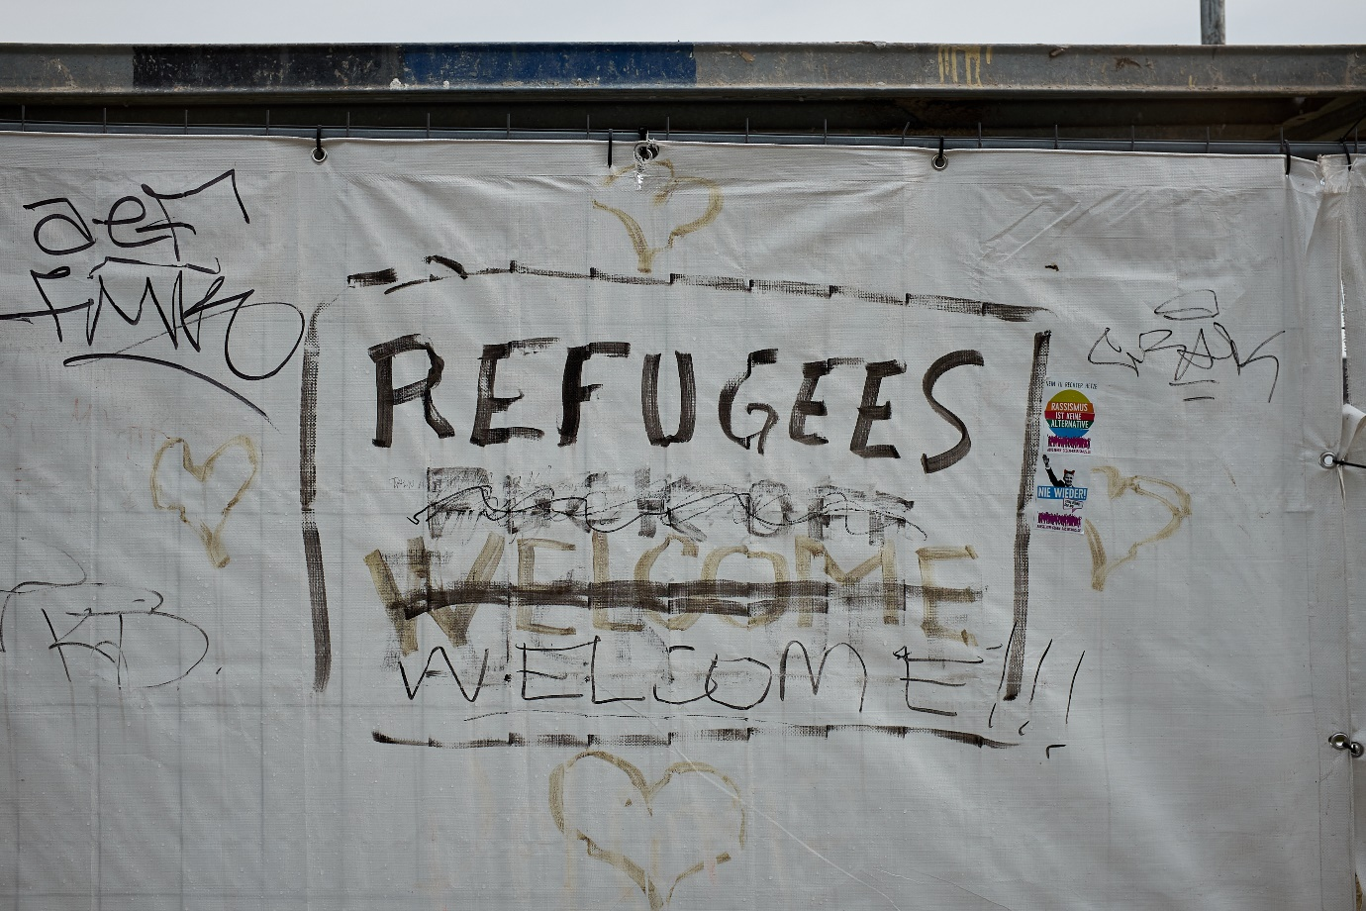
Figure 4 – A Piece by Revenge, Berlin, Germany.
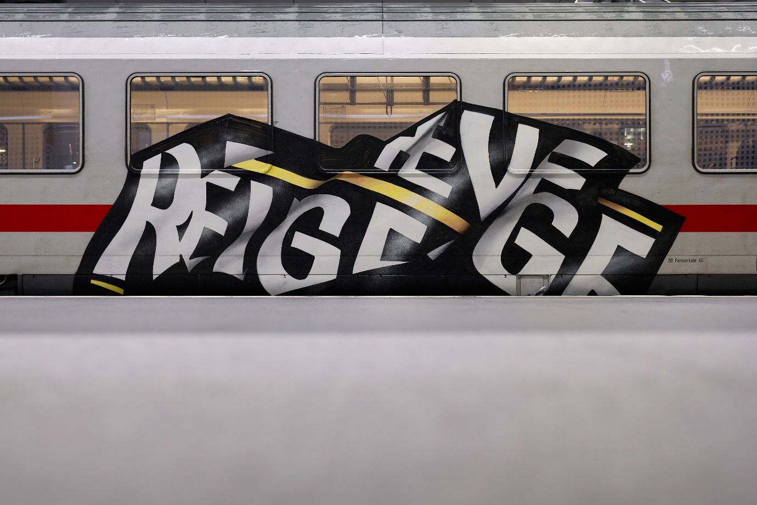

Despite this diversity, several scholars have suggested that there is a common message in all graffiti practices. Graffiti, it all its different forms, reveals and challenges the hegemonic power of property, commerce, and politics that shape our visual environment. Using various urban surfaces as canvases, graffiti “disrupts the aesthetic fabric of the urban environment,” demonstrating that an alternative vision of public space is possible. It reclaims public space from the control of property owners, advertisers, politicians, and city planners. In addition, graffiti resists the confinement of art within specifically designated spaces, such as museums and galleries, and opposes the isolation of art from everyday life. Likewise, it rejects the authority of art institutions to define what “real” art is.

II. Confusion over Graffiti
Social and legal reception of graffiti is highly ambivalent. On the one hand, graffiti painters are often pictured as “vandals” and “hooligans.” Using the “broken windows” theory, several scholars claimed that graffiti invites violent crimes and social decay. Mass media adopted this view, presenting graffiti as a most serious “epidemic” and declaring “wars on graffiti”. Echoing these sentiments, legislators in many countries and cities toughen the “war on graffiti” by increasing existing penalties and introducing new ones (i.e., suspension of a driving license), extending police search powers, and restricting various graffiti-related activities (such the selling of paint. Similarly, judges frequently express their dismay with “graffiti vandalism,” sometimes issuing especially high penalties in a specific case to deter others from painting graffiti.
On the other hand, graffiti, especially in its more accessible forms, is increasingly recognized as valuable “street art” and exhibited in mainstream museums and galleries. Many cities have launched street art projects, dedicating large public spaces to commissioned or uncommissioned murals and creating “legal walls” for graffiti. Melbourne even protects graffiti as cultural heritage. Ironically, the world of commerce – the main target of graffiti criticism – has also embraced graffiti, commissioning famous artists to design shops and advertising campaigns.
This unusual phenomenon of illegal and rebellious activity gaining social acceptance and commercial value creates much ambivalence and contradiction, in terms of both the meaning of graffiti and its social reception. Consider several examples: a successful career of a street artist working legally requires experience as an “authentic,” that is, illegal graffitist. Indeed, real estate firms hire graffiti painters to decorate building facades. This practice increases the attractiveness of neighborhoods and raises real-estate value. Yet starting a legal project may be regarded as “selling out” by the graffiti community and may thus undermine the status of the artist as a graffitist. Commercial firms, such as Sony and Nike, commission graffiti artists to decorate their stores with works that question the culture of consumerism. Similarly, banks acquire graffiti works with prominent anti-capitalist messages. In 2011, a well-known graffiti artist Revok was sentenced to 180 days’ imprisonment for vandalism. While he was serving his time, his works were exhibited at the Museum of Contemporary Art in Los Angeles. The well-known British artist Banksy paints on whatever surfaces he deems appropriate, including private houses and medical clinics, without asking anyone’s permission. His works are highly appreciated, sometimes safeguarded by protective casting, and restored by local authorities when needed. “Vandals” painting over his works are severely condemned in mass media and punished as criminals, while politicians express deep regret for not having done more to preserve the masterpieces on time (Brown 2019). Similarly, painting graffiti over the famous (but mostly illegally created) murals in Melbourne’s Hosier Lane was severely condemned in media, and described as “vandalism of artwork” by Victoria police. Finally, a retrospective of the work of Keith Haring and Jean-Michel Basquiat, both famous and now deceased graffitists, at the National Gallery of Victoria starts with a video showing the artists at work, thus redefining a historic documentation of vandalism as a creation of art.
Legal systems largely mirror the ambivalence surrounding graffiti. In the most common scenario involving a graffiti artist and a court, the artist will play the role of an accused criminal. In such cases, courts label graffiti painters as “vandals” and find them guilty of damage to property, contamination, and other criminal offenses. Yet, in several cases, British judges refused to sentence graffiti painters to jail, acknowledging their artistic talent. In one decision, the judge expressed the opinion that the graffitist could be the “next Banksy.” In rare scenarios, a graffiti painter will play the role of a plaintiff in a civil suit, claiming that her rights have been violated either by a certain use of her work or its destruction. Since graffiti artists typically do not own the surfaces they are painting on, their only feasible legal avenue is a copyright infringement suit. Indeed, courts in different countries occasionally applied copyright law to compensate graffitists for destruction or unauthorized commercialization of their works. Courts accepting the artists’ claims and granting copyright protection to graffiti commonly refer to the plaintiffs as “painters,” “visual artists,” “graffiti artists” or simply “artists.”
The very same activity – creating numerous murals and signing them with the artist’s pseudonym, known as “tag” – can be described very differently, depending on whether the court is about to convict the graffiti artist for vandalism or grant her a copyright protection. Consider a typical description of graffiti as a criminal act:
The State alleges that each vandal had adopted a distinctive tag (pseudonym) and vandalized property with that unique tag again and again for years until it had become their vandalism identity.

And now compare it to a typical description of graffiti as art:
Plaintiffs are well-known and respected graffiti artists. In 2012, Plaintiffs created a mural in San Francisco. […] The mural depicted the stylized signatures of “Revok” and “Steel,” pseudonyms commonly associated with plaintiffs[.]
While in the first case, using one’s “tags” added to the depiction of the accused graffitists as committed vandals, in the second, a factor weighing in favor of recognizing the graffitists’ copyright. The contradictory legal approach towards graffiti indicates a deep misunderstanding between graffiti and the law. As the next Part will demonstrate, court decisions providing copyright protection to graffiti works only deepens the gap between graffiti and law.

III. Graffiti and Copyright – a Dialogue of the Deaf
Graffiti artists occasionally seek legal remedy in the form of copyright protection. Yet, in fact, copyright law lacks appropriate tools for dealing with graffiti. Copyright is based on the presumption that human creativity is predominantly motivated by the prospect of financial gain and, to some extent, by the desire of recognition. These motivations are largely irrelevant for graffiti painting, since the artists obviously do not expect any economic profit from their activity and mostly stay anonymous, at least for the large public. The remedies that copyright law may offer naturally reflect its basic presumptions about human creativity. Accordingly, copyright law’s remedies include economic compensation, the right to be credited as the author and the right to preserve the integrity of one’s work against modifications and destruction. Graffiti painters occasionally do apply for these remedies, which are actually the only benefits the legal system can offer them. Yet, these remedies are entirely dissonant with the core logic of graffiti culture, which presumes creating without the prospect of economic gain or open public recognition – since signing works with one’s real name would be akin to admitting having committed a crime – knowing that the works are very likely to be modified, painted over or destroyed altogether.
Consequently, copyright cases dealing with graffiti paintings are often reminiscent of a dialogue of the deaf. For instance, the Supreme Court of Germany denied a copyright claim of a graffiti artist, based inter alia on the fact that he did not sign his work. Likewise, another German court found that an artist who let some segments of his work be painted over with other graffiti is not entitled to copyright protection. Conversely, the Supreme Court of Germany ruled in favor of graffiti painters who openly published their names and “did not stay anonymous like most graffiti artists do.” Similarly, a US court refused to grant copyright protection to graffiti paintings where the artists knew their works were temporary and would soon be painted over. In other words, the more artists deviate from the common norms of graffiti culture – signing their works with their real names or protecting them against other artists – the more understanding they are likely to find in a court.
Both US-American and German courts consider fame and commercial success as factors that weigh heavily in favor of copyright protection. Renowned graffiti artists – specifically those who have exhibitions in mainstream art galleries or museums, and can demonstrate that their name has a significant economic value – are most likely to gain copyright protection. Thus, as already mentioned, the famous and highly evaluated Banksy’s murals are now protected against “vandalism” – that is, painting over by other artists. To be able to tell vandalism and art apart, courts hear expert witnesses, such as art professors and experts, as well as owners of galleries, museums and private collections. All these legal practices exclude the core of graffiti culture from the scope of legal protection. For these artists remaining anonymous is a necessity in order to avoid prosecution. Thus, anonymous artists experimenting with new styles, working only for the sake of art and without an expectation that their works will be preserved, bring them money or recognition, cannot enjoy any legal benefits. Only those who depart from the core of graffiti culture to become mainstream artists may do so.
To illustrate the dissonance between the commercial logic of copyright and the graffiti culture, let us consider two legal stories –one American and one German.
In the US, the most significant legal treatment of graffiti concerned the story of 5Pointz, a site located in Long Island City, New York, which became a “graffiti mecca” in 2002. Unlike in a typical graffiti story, the paintings were made with the consent of the property owner. He even appointed a curator who controlled all the artistic activity at the site and decided who will paint, where the paintings will be made and how long they will stay on the walls. Yet, all the paintings were made without any economic compensation, and the curator, a graffiti artist himself, did not receive any monetary benefits either. In 2013, the owner of the buildings decided to tear them down to make way for high-rise luxury condos. The artists applied to the District Court of New York for a preliminary injunction prohibiting the planned demolition.
To decide whether the paintings can be protected against destruction, the court had to establish whether they are works of “recognized stature,” as Visual Artists Rights Act requires. While interpreting this vague term, the court relied upon testimonies of art professors, as well as owners of well-known galleries and private art collections. It ultimately found that only works that were painted on “long-term walls” – that is, were intended to stay on the walls and not be painted over – were capable of copyright protection in the first place. Among these, only works of world-renowned artists, whose paintings had been acquired by museums, featured in movies, discussed on the TV, in newspapers and scholarly articles were found to satisfy the requirement of a “recognized stature.” The court demonstrated deep understanding of the cultural value these artworks bring to the city of New York and the general public. In a concluding remark, it stated:
Picasso believed that “[t]he purpose of art is washing the dust of daily life off our souls.” […] This fits the aerosol artist to a “T,” and our souls owe a debt of gratitude to the plaintiffs for having brought the dusty walls of defendants' buildings to life.
It may thus come as a surprise that the court ultimately refused to grant an injunction preventing the destruction of the artworks. In a puzzling contradiction to its high appreciation for the artistic value of the works, the court held that any damage caused by their destruction can be later compensated with money, and hence, there is no reason to prevent the owner from using his right to demolish the buildings:
In any event, paintings generally are meant to be sold. Their value is invariably reflected in the money they command in the marketplace. Here, the works were painted for free, but surely the plaintiffs would gladly have accepted money from the defendants to acquire their works, albeit on a wall rather than on a canvas. (emphasis added)
This decision is another attempt to bring the unique phenomenon of creativity for its own sake under the familiar copyright umbrella that understands creativity mainly in monetary terms. It is not clear what led the court to the conclusion that “the plaintiffs would gladly have accepted money from the defendants to acquire their works.” It illustrates the sea of misunderstanding that lies between graffiti culture and copyright law. Indeed, it is somewhat ironical that the only thing both German and the US legal systems may offer artists deliberately working for free is money.
After the owner of the 5Pointz buildings whitewashed the paintings, the artists filed a suit for damages before the same court, and were heard by the same judge. This time the court found that the paintings “did not have a provable market value,” apparently departing from its previous holding. Nevertheless, the court expressed a great discontent with the owner’s behavior, found that he could have provided more time for the artists to remove their works – contradicting its own holding that this was physically impossible – and ultimately ordering him to pay the highest possible sum of statutory damages for each work, amounting in total to almost seven million dollars. Remarkably, the court condemned the property owner using language that is much more suitable for a convicted criminal than a civil wrongdoer:
Wolkoff has been singularly unrepentant. He was given multiple opportunities to admit the whitewashing was a mistake, show remorse, or suggest he would do things differently if he had another chance. He denied them all[.]
These two decisions show the inadequacy of copyright tools in the context of graffiti, their inability to capture the real value of the works, their significance beyond money. The fact that the court did not prevent the destruction of the works, but later expressed a deep dismay with the owner who whitewashed them looks like a sign of understanding one’s own helplessness. Another interesting point here is the issue of compensation. While in its the first decision, the court essentially states “well, everything has a price at the end of the day,” in the second it casts a doubt on this assumption, but ultimately grants the artists the largest sum possible. This generous decision seems more like a punishment of the owner than a compensation of the artists though.
Apart from these difficulties, it is interesting to consider the works that were left outside the scope of legal protection by the court: works that were painted on “short-term walls” and were supposed to be replaced by other works after a while, as well as works that were not recognized as masterpieces by the professional experts. In other words, it is the works that belong to the core graffiti culture that were left without any legal remedy.
In Germany, a number of judicial decisions dealt with graffiti artists who painted on the Berlin Wall in the 1980s. After the reunification of Germany, the state sold some of the wall pieces bearing graffiti, gave others as a present, and renovated the rest of the wall, sometimes destroying existing works. These acts were objected by some of the graffiti artists and gave rise to numerous copyright suits. German courts had to deal with challenging questions, such as how to apply the doctrine of first sale – which holds that once the copyright owner has distributed her work, she cannot control consequent transfers of the same work – on graffiti.
Trying to follow the logic of graffiti culture, the Chamber Court of Berlin held that the act of painting in a public place equals first sale, since this kind of publicity was the very goal of the artists and the ultimate expected reward for their work. The artists could not have expected any pecuniary gain at the time their works were created, and hence, cannot later claim a right to participate in the revenues gained from selling of the wall pieces. The Supreme Court disagreed, finding that only after the Wall was broken down into pieces, did it become possible to sell the paintings. Since the paintings gained wide recognition and drove the auction prices of the Wall pieces up, the artists should be compensated for the value their works added to the historical artefacts. That is, only the remarkable historical event that made the works famous and commercially valuable allowed copyright law to extend its protection over them.
In an interesting obiter dictum remark, the Court noted that the owner of the Wall surely has the right to destroy Wall pieces together with the paintings, but not the right to sell them without the permission of the graffiti artists. This somewhat strange position demonstrates the difficulty of applying copyright law, which is designed to protect works made in a prospect of financial gain, on works made illegally and without such intention.
As these two legal stories illustrate, even when legal systems seek to protect graffiti artists, legal tools prove inadequate to capture the spirit of this cultural phenomenon and provide it with suitable protection.

IV. A Larger Context: The Social Ambivalence around Non-Profitable Creativity
Departing for a moment from the legal context, consider that at a more general level, the social attitude towards actions that are not motivated by profit is highly ambivalent. Thus, for example, the famous fable “The Ant and the Grasshopper” tells a story of a hard-working ant, who gathers and stores up food for winter and the careless Grasshopper, who spends the summer singing and dancing. When the winter comes, the starving Grasshopper begs the Ant for food, but the Ant tells it to “dance the winter away.” The Grasshopper dies of hunger, which is regarded as a punishment for its idleness. Work – notably, creative expression – without any prospect of benefit is pictured here as worthless and even objectionable.
On the other hand, the romantic figure of a starving artist, who sacrifices his own material well-being for the sake of his work is also deeply rooted in our social folklore and appears in many works, such as La Boheme and A Hunger Artist. Many stories of famous artists, such as Mozart and Modigliani, are pictured along these lines. Works created without the prospect of financial gain, or even under the danger of a punishment, often attract much interest and are considered especially valuable, being an authentic expression of one’s feelings and thoughts. For example, Goya’s non-commissioned paintings attract far more attention than those he drew as a court painter.
The inconsistent social approach towards non-compensated creative work is understandable: while it is easy to assume that commissioned or otherwise compensated work is valuable – the value being expressed in the revenues it creates – it is very hard to appreciate the value of a non-compensated work. As we all know, unsuccessful artists only rarely turn out to be Van Gogh or Modigliani. As Virginia Nicholson notes, “[f]ifty years on we may judge that Dylan Thomas's poverty was noble, while Nina Hamnett's was senseless.”
The ambivalent social approach towards non-compensated creative work is reflected in accordingly contradictory legal rules. Thus, while commercial speech is considered as the least valuable type of expression, legal rules governing physical and intellectual property actually make it the most prominent and pervasive type of speech. By contrast, although disinterested speech is formally entitled to the highest form of legal protection, it is often banned or otherwise excluded by the rules of physical and intellectual property.
In addition, copyright law functions by protecting works against copying and thereby providing an economic incentive to create and make profits from one’s creation. Hence, since copyright is based on the prospect of gain, it very much favors paid speech over non-paid one.
An additional feature of the legal system that pushes paid speech into the center of social attention is the mechanism of physical property: the idea that everything should be owned by private or public entities. Notably, public entities act very much like private actors in this context, establishing their own rules of property use rather than leaving space for free social expression. For instance, spaces that belong to municipalities or the state and may reasonably bear expressive messages are usually used for commercial advertising instead.
Hence, we ultimately find ourselves very much surrounded by speech that is motivated by the prospect of some kind of an economic gain. Undoubtedly, this kind of speech may be very valuable: for instance, movies, newspapers, books, and art exhibitions all involve some prospect of gain. Other types of economically motivated speech, such as commercial advertising or sponsored articles, are less meaningful in terms of social discourse. But what about disinterested speech, i.e., speech that is not motivated by any prospect of profit whatsoever? Although formally recognized as the most valuable type of speech, it is practically squeezed out of the social discourse and largely left with no genuine chance of being heard.
This legal dichotomy between the high appreciation of disinterested speech and its actual suppression is especially prominent in the field of graffiti, as shown above. Sentencing some graffiti artists for vandalism while providing others with copyright protection, the legal system reflects the social attitude toward non-compensated creativity: we can only know it is art and not nonsense after it has gained commercial value and social recognition. This brings the general legal attitude favoring speech with a commercial value over speech without such value into the field of graffiti art.

V. Proposals on the Legal Regulation of Graffiti
Legislators and scholars from different disciplines have made numerous proposals regarding the legal regulation of graffiti. Graffiti opponents naturally advocate strengthening criminal punishments – some of them going as far as to propose caning of graffiti painters – and denying graffiti copyright protection while graffiti supporters suggest a wide range of possible measures. Some of the latter argue that cities should provide more legalized spaces to allow artistic expression, and offer graffitists art education programs. Others still advocate partial or full copyright protection for all or some graffiti works; preservation of significant artistic works as cultural property; recognition of graffiti as constitutionally protected speech under certain circumstances; and introduction of a set of common law privileges to “trespassory art.”
Another line of writing rejects such measures. Some scholars point out that legalized spaces and art programs reduce graffiti to its aesthetic dimension and submit it to the very systems of property governance and institutional art hegemony it is challenging, thus ignoring and diluting its rebellious nature. Others argue that graffiti should not be granted copyright protection, since the economic incentives copyright offers are irrelevant to the motivations of graffiti painters, whose creativity is flourishing without them. This argument connects to a larger body of scholarship debunking the basic assumption of copyright law that economic incentives play a central role in the promotion of creativity. Scholars further argue that copyright protection may actually harm creativity and innovation in the field of graffiti, explaining that the inner rules of graffiti culture successfully fill in the “negative space” left by copyright, and there is no need for additional regulation.
In another vein, some scholars oppose copyright protection of graffiti because such protection signals governmental support and thus counteracts this art form’s counterhegemonic message. Similarly, others advocate preserving criminal sanctions against graffiti, since illegality and the risk of punishment are crucial to the expressive message of graffiti. Legalizing graffiti would arguably defeat its transgressive power and turn it into mere entertainment.

VI. Rethinking Graffiti
The goal of this essay is to introduce a novel perspective on graffiti regulation. The severe measures taken so far to eradicate this practice have failed: at best, they have managed to displace graffiti, but not to eliminate it. We agree with the scholarship arguing that providing more “legal walls” will not solve the problem, and that copyright protection is inappropriate in this field. Yet, we disagree with the argument that graffiti should be criminalized in order to safeguard its rebellious character. Graffiti indeed expresses a dissenting voice. This voice can potentially provide us with valuable information about injustices in the current order of property distribution. Preserving this voice by its continuous suppression is not enough. By way of analogy, while criminal punishment played an important role for the US sit-in movement, its real victory was the Civil Rights Act of 1964, which banned discrimination and segregation on the basis of race.
Research on graffiti has so far studied it as a social, criminological, or artistic phenomenon that should be suppressed, encouraged, or appropriately manipulated. Scholars who oppose and those who support graffiti all focus on its external form, perceiving it as either desirable or undesirable.
This essay offers an alternative perspective. In their seminal article “Property Outlaws,” Sonia Katyal and Eduardo Peñalver identified the phenomenon of expressive “property outlaws” – lawbreakers who do not intend to acquire property for themselves, but to express a dissenting view. They have argued that expressive outlaws may communicate valuable information, revealing injustices in property law, and possibly contributing to its evolution. Graffiti is a prominent example of an expressive “property outlaw,” lawbreaking activity done for purely expressive purposes. Indeed, as “property outlaws,” graffiti painters seek to reveal injustices in property law and offer a vision of an alternative reality. As Jean Baudrillard suggested, the subtle message of graffiti “must be heard and understood.” Doing this, in the legal sphere, is the central goal of this essay. Instead of encouraging or suppressing graffiti, we propose attending to its political message and introducing a legal change along its lines.
So far, legal systems have distanced themselves from any attempt to understand graffiti – as shown above, they either punish graffiti painters as vandals or judge them with criteria such as market worth, fame and recognition by mainstream culture – criteria that are foreign to graffiti culture and dissonant with its core values. Although graffiti has been around for many decades, the following quote from a judicial decision accurately captures its prevailing perception in current legal practice:
I don’t understand the mentality of people who go around […] vandalising walls and other items around the city. […] I had first-hand experience of that recently and people out there are not getting the message.”
The essence of our proposal is that the legal system should “get the message” of graffiti, that is, discern the informative value of this expressive lawbreaking. This way of thinking about graffiti will mark a sharp contrast to attempts to regulate it in one way or another that have been undertaken so far.

VII. Shifting the Borderline between Property and the Public Space
We suggest redefining the boundaries of physical property so as to restrict – with certain exceptions – private and public owners’ control over surfaces that shape our urban landscape. These surfaces will then be used as a medium of free visual expression, subject to general limitations on free speech, such as libel, incitement, and obscenity. This will reconceptualize the shared spaces as a public “forum” in its classic sense, that is, a place of discussion, opinion exchange, and purely aesthetic or even entirely incomprehensible expression. It will grant city residents the right to design their urban spaces as an ever-changing collage of their expressions.
To be sure, this idea sounds radical: if we take the example of a building, the walls belong to its owner; how can they possibly be expropriated? Yet, it is useful to keep in mind that property right is a bundle of privileges established by law; the precise content of this bundle undergoes changes from time to time, inter alia, in response to external pressures. Consider that at the time of the first sit-ins, it was unimaginable that a grocery shop owner would be obliged to open his store to Afro-Americans, but the Civil Rights Act did just that, redefining the boundaries of property.
Some walls are indeed the outer side of buildings belonging to someone. As such, it may be natural to perceive them as part of the owner’s property. Nonetheless, our public space is contained between these multiple surfaces: buildings’ exteriors are the inner walls of the public spaces we all share. In this sense, the public and the property owner are similar to neighbors living on opposite sides of the same wall. From this perspective, the question of who should determine the appearance of city walls – those who live on one side or those who spend their time on the other – may seem less obvious. The right to control the appearance of walls is even less evident with regard to corporate and public owners, since these entities cannot actually “live” behind them.
Moreover, under current legal regimes, outer surfaces do not fully “belong” to their owners; their appearance is subject to various urban regulations. Notably, some jurisdictions allow public officials to enter private property and remove graffiti against the owners’ will or require property owners to remove it at their own cost. Thus, an owner’s right to control the appearance of outer walls is already significantly restricted; it is municipal officials who largely exercise this right. Since the latter represent the public, it can be further contended that the public already owns a large proportion of the right to determine the appearance of city walls. Hence, to a significant extent, the proposed change would occur between different regimes of public ownership rather than between private and public ownership regimes. In other words, we suggest that the public should determine the appearance of walls in a decentralized process emerging from multiple individual initiatives rather than in a centralized political process.
Furthermore, as several scholars note, the neat and tidy look of a city is far from being neutral. It represents the control of property owners and politicians; their social and cultural dominance. In this sense, the fierce fight against graffiti is as expressive as graffiti itself. Kimvall has even argued that the removal of graffiti is a form of iconoclasm, an ideological destruction of visual images. Indeed, authorities often seek to distort graffiti images, even without removing them, with the sole purpose of defacing the painting (see Figure 5). Thus, the war on graffiti is not a contest between expression and lack thereof, but between two conflicting types of expression – one monolithic and authoritative, the other polyphonic and personal.

Figure 5 – Graffiti image distorted by stickers of Berlin Public Transport Company (BVG)
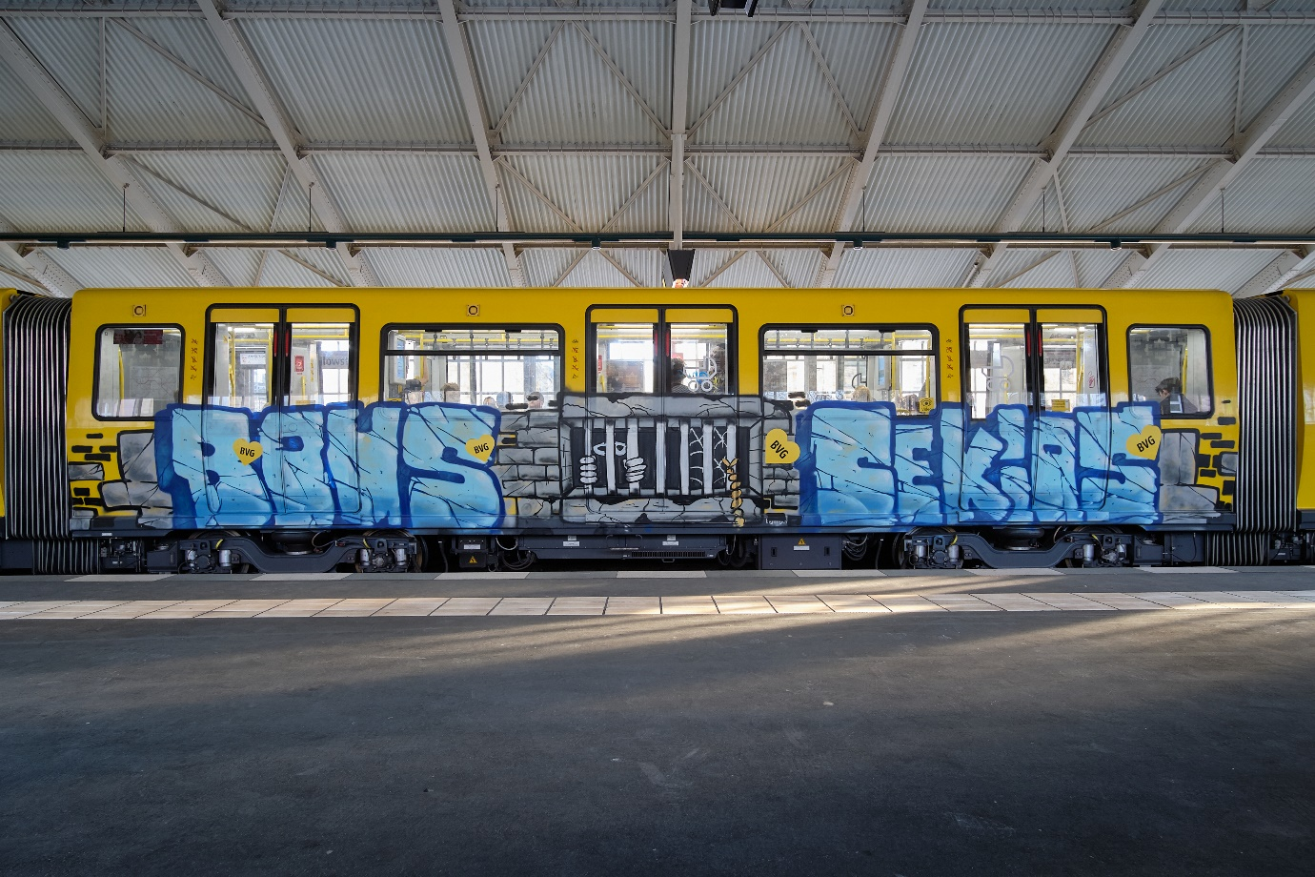
Redefining urban spaces as a genuinely public sphere is especially important given the growing trend of creating “privately owned public spaces” (POPs). Indeed, many cities across the globe increasingly privatize significant urban spaces, including plazas, arcades, parks, squares, gardens, and atriums. Although these spaces continue to appear as public, in fact they are owned, managed, and controlled by private entities. These entities considerably restrict the residents’ freedom of action within POPs, disallowing, for instance, any forms of demonstrations and protests, and even banning photography. POPs redefine public spaces as sites primarily designed for consumption, thus driving out spontaneity, free expression and social interaction. The growing tendency of creating POPs thus tends to reduce our social participation in public sphere to the liberty to consume. As Bradley Garrett puts it, POPs create “dead” spaces – “not dead because they aren’t enjoyable […], but dead because the potential range of spatial engagement [t]here can fit in a coffee cup.” Restricting the control of property owners over urban surfaces and reimagining them as sites of free expression has the potential to counteract this tendency of disempowering our public sphere.
In addition, private and public property owners frequently enable advertisement on the surfaces they control, thereby saturating our living environment with commercial messages. Commercial entities enjoy substantial legal and economic privileges, which result in large corporations having a much stronger voice in the public discourse than living human beings. This unjustified advantage produces a “market failure” in the marketplace of ideas, thus endangering democratic discourse. The legal change proposed here seeks to open up the “marketplace of ideas” that emerges in our physical environment.
Our proposal corresponds with the discourse on “the right to the city.” A term coined by Henri Lefebvre, the right to the city entails two rights for city inhabitants: participation in decision making regarding public space, and appropriation of it – the latter being the relevant aspect for the current discussion. Following Marx, Lefebvre distinguishes between the use value of city spaces and their exchange value, e.g., urban space as real estate belonging to a corporation. The right to the city does not refer to private ownership (exchange value), but rather to maximization of use value for residents over the exchange value for others. The ideal of urban citizenship and democratic participation is frequently limited either by class differences (marginalization and exclusion) or political pressures. This calls for reconceptualizing the distribution of power and a new understanding of human rights. Discussing the right to the city, David Harvey suggests:
The right to the city is far more than the individual liberty to access urban resources: it is a right to change ourselves by changing the city. It is, moreover, a common rather than an individual right since this transformation inevitably depends upon the exercise of a collective power to reshape the processes of urbanization. The freedom to make and remake our cities and ourselves is, I want to argue, one of the most precious yet most neglected of our human rights.
The right to the city is the right of the residents to actively engage in the creation and recreation of their shared spaces rather than passively access an environment shaped and policed by property owners and city planners. This is a right to create public spaces as a commons of active democratic participation. Although it is far from clear how the right to the city should be asserted, allowing writing and painting on city surfaces is plausibly an important step in this direction.
Likewise, our proposal echoes Hannah Arendt’s concept of genuine freedom as the liberty to act; that is, to take initiative and introduce something new, unexpected and unpredictable into the public sphere. The exact outcomes of the proposed paradigm shift are naturally difficult to predict, as it is impossible to know in advance, what kind of expressions individuals will produce when given the freedom to shape and reshape public spaces. Yet, this unpredictability is a general feature of a free discourse and should not be a matter of concern. The proposed change is likely to greatly enrich our public discourse, making it genuinely inclusive and democratic. It is expected to promote understanding between the different social groups and act against the current political polarization. Unlike social media that enables one to hear only the opinions one already holds, the current proposal would expose every society member to a plethora of social voices.
In addition, introducing a right to express oneself on city surfaces is likely to spur human creativity. Unlike copyright that seeks to spur creativity by offering economic incentives, our proposal seeks to promote creativity simply by providing the opportunity to express oneself on publicly visible spaces, akin to an “ideal speech situation” envisioned by Jürgen Habermas. Consequently, unlike profit-motivated creativity that blossoms under the current copyright regime, it is creativity of people wishing to express themselves and be heard that is likely to flourish under the proposed regulation. Psychological research shows that the prospect of gain has an adverse effect on creativity. Hence, allowing significant public space for free expression may result in a richer spectrum of expressions that the one currently created within profit-oriented platforms. Another important point here is the artists’ perspective: allowing free and authentic expression is an important goal in itself, irrespective of its effect on the public domain. Such expression contributes to the development of one’s personality, and as research shows, non-compensated creative work brings more joy and satisfaction than compensated one.
Relatedly, introducing a right to design one’s city is likely to promote human well-being by enabling more communication, spontaneity, freedom, creativity, and social involvement – important factors of personal flourishing. In addition, the never-ending flood of messages that promote consumption as the ultimate vision of a good life makes it difficult to aspire to different values; yet materialism actually undermines personal well-being. Creating a significant space for non-commercial expression may ease the hold of consumerist ideology on our minds, thereby advancing overall human well-being.

VIII. Who’s Afraid of Graffiti?
The legal change this project suggests requires a major shift in our thinking about private property, public space, and the boundaries between the two. In fact, it proposes introducing a new legal right – the right to the city’s surfaces – while at the same time limiting existing rights, most notably, private and public property rights. This proposal naturally raises the question how this new right will function in practice – will people indeed take the opportunity to express themselves? Will a meaningful dialogue develop? Will we see more of hate speech and pornography on city walls? These concerns are natural and reasonable. Notably, throughout history, major shifts in the direction of decentralization of power have usually been accompanied by similar doubts related to the question whether people will make a sensible use of the new right. For instance, the abandonment of sumptuary laws, censorship and slavery; the introduction of voting rights for women and Afro-American people – all these processes have seen opposition and disbelief as to whether the new rights would be used reasonably rather than lead to chaos and disorder. How will people dress if permitted to wear whatever they please? What will the press look like if the state has no control over its contents and everyone is allowed to print? How will women use their right to vote? Taking control away from society and putting it into the hands of individuals has always been a process fraught with misgivings. Similarly, it is difficult to anticipate now how city surfaces will look if residents are allowed to write and paint on them.
We believe that introducing the right to design city surfaces will have overall positive effects on the residents’ lives, in various aspects, as the following text explains.
Freedom of speech is a hallowed principle in modern democracies. While, theoretically, every person has an equal right to express herself, on a practical level, the opportunities to meaningfully exercise this right, that is, to be heard by relevant audiences, are far from equally distributed among members of society. As is well known, only a small number of people have access to media that would disseminate their views. This access is strongly associated with political, social and economic power. Consequently, public discourse is dominated by those who already enjoy a privileged position in society, thus reinforcing the conventions securing their position of power. At the same time, most individuals lack the means to participate in any meaningful way in public discourses. Specifically, weak social groups are often underrepresented in such discourses or entirely excluded from them, so that their voices are barely heard or not heard at all. Providing a public forum where all voices will have an equal opportunity to be heard has the potential to change this picture, making social discourses more inclusive and egalitarian.
Partaking in or simply being exposed to vivid discourses taking place on urban surfaces may have further positive effects in terms of democratic participation. Observing expressions on social issues about which one has not been aware (or insufficiently so) may increase one’s concern about these issues. Bringing different social issues to the fore may thus reduce civic apathy and raise social awareness.
Anticipating that a legal rule allowing writing and painting on city surfaces would render positive social changes might sound contrary to the widespread opinion linking graffiti to crime. Indeed, drawing upon the so-called ‘broken windows’ theory, several scholars have argued that graffiti represents unresolved disorder and lack of control, inviting further antisocial behavior, possibly leading to more serious crimes and creating an atmosphere of discomfort and fear among the residents. Urban authorities and the media have extensively relied on this view to create a climate of social hostility towards graffiti. Other scholars have contested this view, challenging the existence of the causal link between graffiti and anti-social behavior and crime.
A further line of writing argues that the media, as well as urban and state authorities react to graffiti in a highly disproportional way, creating a ‘moral panic’ and helping to construct a social attitude to graffiti as a crime and to graffiti painters as vandals. The reason for this overreaction arguably lies in the subversive message graffiti sends: this message challenges the current hegemony of property, politics and commerce over the urban space, making its own claim to the city. This naturally causes much opposition and unrest on the side of the respective players, who use their powerful social position and access to mass media to create the image of a graffiti painter as a dangerous vandal who threatens the personal safety of the city’s residents.
One’s acceptance or rejection of the existence of a causal link between graffiti and anti-social behavior or crime, however, bears little relevance for the proposed legal change. In this regard, consider Wilson and Kelling’s discussion of graffiti on subway cars from the perspective of the “broken windows” theory:
What to some aesthetes is folk art is to most people a sign that an important public place is no longer under public control. If graffiti painters can attack cars with impunity then muggers may feel they can attack the people in those cars with equal impunity .
In other words, the alleged negative effects of graffiti – to the extent that they exist – are strongly related to the fact that it is currently defined as a criminal act. The presence of graffiti, then, may send the disturbing message that law is not enforced, encouraging further crime. Once writing and painting on city surfaces are permitted, the presence of graffiti should no longer be associated with a lack of law and order. Hence, allowing writing on urban surfaces is not expected to lead to criminal activity or to provoke feelings of unsafety among residents. Notably, no research has ever indicated that permitting painting on “legal walls” engenders feelings of discomfort or is in any way associated with crime. On the contrary, cities with significant “legalized” graffiti spaces, such as London, São Paolo and Melbourne, witness these areas becoming important urban sites of interest, attracting tourists and local residents alike.
An additional concern we would like to address is objectionable speech, such as incitement and obscenity. Because some portion of today’s graffiti includes these types of speech, it would be reasonable to ask whether the proposed legal change would not lead to its proliferation. We believe that the fears stemming from this concern would not be borne out in reality. Today, graffiti is made by a tiny fraction of the population that is willing to break the law to express its messages. Whatever is created by this small group – be it masterpieces on a train or racist messages on a building – cannot be regarded as indicative of what would be created by residents who are currently not participating in the discourse taking place on urban surfaces. Significantly, there is no evidence that “legal walls” attract objectionable speech, which could indicate that one should not expect this kind of speech to proliferate once free writing and painting is allowed.
We anticipate that rather than exacerbating anger, polarization and racism, allowing free writing and painting on urban surfaces will promote understanding between various social groups. Scholars have noted that the proliferation of social media leads to polarization and radicalization, removes the common basis for social discourse and reinforces prejudices and anger. This happens because social media provides specific contents for each user, based on his or her previous preferences and the popularity of the contents. In this way, the user receives contents that match his or her existing views. Moreover, because contents representing radical ideas tend to be more popular, the contents the user receives tend to radicalize as well, naturally leading to an escalation of the user’s views. This process isolates different social groups from one another, spawning different universes in terms of topics that are considered important, opinions, and even basic facts, such as which events took place in reality. In addition, while partaking in social media discussions, individuals remain invisible to each other, which often results in much less respectful discourse than would have taken place in real life. All this naturally widens the conflicts between social groups, undermining the possibility of common dialogue and mutual understanding.
Allowing free expression on urban surfaces has the potential to remedy these disadvantages of social media by creating a place of mutual public discourse. Unlike in social media, whose “filter bubble” directs our attention only to like-minded agents and attitudes, all the passersby, regardless of their previous views, will see a writing or painting on a city wall. This would expose everyone to a plethora of social voices, spurring city residents to consider issues they had not considered before, and raising their awareness of other social groups. Paintings bearing no specific message also have the potential to make people conscious of the presence of others, expressing the simple idea: “I am here” or “I live here, too.” Since popularity will play no role in the availability of the different contents, moderate and mediating views will have a chance to be heard. In addition, because writing and painting on city walls has the potential to involve real-life exchanges with other people, we expect to find much less disrespectful language than one encounters in the virtual environment of social media.
A further possible concern with the proposed right to paint and write on city surfaces is that some people might feel uncomfortable with the environment looking less orderly and more dirty overall. One factor that could mitigate this effect is the fact that dirt is a relative, rather than an absolute, concept. As Douglas clarifies,
[T]here is no such thing as dirt; no single item is dirty apart from a particular system of classification in which it does not fit. […] But what counts as dirt? It depends on the classifications in use. Dirt is essentially disorder. There is no such thing as absolute dirt: it exists in the eye of the beholder. […] Dirt offends against order.
Hence, our perception of something as dirty or orderly tends to be a question of what we expect to find and what we regard as appropriate for a specific place. For instance, if a child tapes a banana to a wall in her bedroom, her parents might perceive this unexpected action as creating dirt. The very same act done by an artist in a museum may be considered valuable art, since in this setting, we expect to see novel uses of materials. By the same token, permitting writing and painting on city surfaces may change the social perception about the proper place of such creations. Once people expect to find writings on city surfaces and become used to this practice, such writings will no longer be perceived as dirt.
It is worthwhile to mention that allowing or commissioning artists to paint a previously blank wall does not prompt a perception of this wall as dirty, which brings us to the next issue: a concern about whether people untrained in art would create meaningful artistic expressions. This is a point where the project touches upon one of the most puzzling social phenomena – modern art. Indeed, the current social perception of art is unique in its combination of wide-open and restrictive elements. On the one hand, the perception of art has undergone significant liberalization, perhaps reaching the ideal of being “unbound to any form,” akin to an idea envisioned by Kazimir Malevich: “In 1913, trying desperately to liberate art from the ballast of the representational world, I sought refuge in the form of the square.” Modern art is largely limitless in form, encompassing a toilet sink, as in the famous Marcel Duchamp’s sculpture, and dissected human and animal bodies, as in Gunther von Hagens’s exposition “Body Worlds.” Any object may become a work of art when an artist decides to designate it as such. In the field of painting specifically, abstract and other unconventional art forms – for instance, Jackson Pollock’s technique of pouring or dripping paint on a canvas – are exhibited in museums and command high market prices.
This highly inclusive attitude toward art, however, is confronted by another social tendency: to perceive only those few individuals who have been singled out by art experts and art institutions as artists, and to regard only works created by these individuals as “genuine” art. Additional factors that dictate the social perception of what counts as art are fame and, consequently, market value of the artworks. This results in a very small group of individuals – recognized by both art experts and the market – been perceived as artists, to the exclusion of all other people who create artistic works.
The coexistence of these two opposing trends, the ultra-open one and the closed tight-as-a-drum one, leaves many people quite confused and dubious of their capacity to judge any artwork at all. In studies, participants can distinguish paintings made by well-known modern artists from creations of toddlers, chimpanzees, and elephants at a rate only slightly above chance. When told that a certain picture was painted by a famous artist, people tend it evaluate it much more favorably. In 2013, Banksy sold his original and signed paintings in New York City’s Central Park for as little as 60 USD. Although his paintings sell for millions of dollars at auctions worldwide, he had a hard time finding buyers in the park: no one knew it was the “real Banksy.”
Identifying the work of famous artists is by no means intuitive for most people. Meanwhile, the art world singles out as artists a very small number of individuals, to the exclusion of all others. This puts art institutions and market forces in a highly authoritative position to define what should be appreciated as art.
Protecting only street art that has gained social and professional recognition, the legal system further reinforces the existing hegemony in the field of visual arts. This position is unjustified. The field of visual expression needs space for free and uncontrolled creative discourse, space that would provide opportunity for various voices, especially those that have not yet been heard. It is necessary to allow meaningful public spaces for expression without the prospect of commercial gain, art for the sake of art.
There are enough incentives to create art works that seek to fit into existing narratives thereby acquiring professional and public recognition. What is missing is space for art that would not take these considerations into account, but simply emerge as an expression of one’s creativity. Such works have the potential of being especially interesting, authentic and innovative, and thus may greatly enrich our cultural landscape. The proposed legal change has the potential to advance a shift away from the current hegemony of art institutions in the direction of a more inclusive social perception of who artists are and what art is.

XI. Conclusion and Further Research
In this essay, we have proposed a novel perspective on graffiti: instead of suppressing, manipulating or adorning it, we suggest attending to its political message and responding it with a corresponding legal change. Specifically, we have put forward the idea of changing the existing regime of property rights so as to restrict the owners’ control over surfaces that shape our urban landscape. Instead of being controlled by property owners, city planners, and advertisers, publicly visible surfaces should be freely used by city residents as a means of visual expression. We believe that despite possible concerns, introducing the right to determine the appearance of the city in a free and unregulated way will have positive effects in terms of promoting genuinely egalitarian social discourse, liberating the concept of art, increasing understanding between different social groups, and enhancing overall human well-being.
This essay is a first step in the direction of the proposed legal change. Further research is needed to propose and elaborated legal regulation that would adopt the proposed change. For instance, the new right to paint and write on urban surfaces will require changes in the existing copyright regulation, excluding the protection provided by “moral rights” against modifications and destruction of artworks. To take another example, because of the high visibility and potential durability of expressions on urban surfaces, more stringent limitations of free speech than the general ones might be in place. In other words, our essay puts forward a general idea, inviting further research to suggest specific contours of the proposed legal change.

* Katya Assaf-Zakharov is an Assistant Professor at the Law School and the DAAD Center for German Studies of the Hebrew University of Jerusalem. She can be contacted at katya.assaf@mail.huji.ac.il. Tim Schnetgöke is a professional photographer and a connoisseur of vandalism, specializing in portraits and extensively documenting graffiti on trains. He is based in Berlin, Germany, and may be contacted at info@schnetgoeke.com. The authors would like to thank Nufar Avni, Nir Barak, Avner De-Shalit, Christian Fernando Iaione, Annette Kur, Hephzibah Levine, Eynat Mendelson, Renate Meyer, Dan Miodownik, Gillad Rosen, Emily Silverman, Sharon Shakargy, Raanan.Sulitzeanu-Kenan Eyal Zamir, and Anna Zika for their invaluable comments, insights, and suggestions.
Jeffrey Ian Ross, History, Types, and Writers/Artists of Graffiti and Street Art: Introduction, in Routledge Handbook of Graffiti and Street Art 11-15, 11 (Jeffrey Ian Ross ed., 2016).
Jean Baudrillard, Kool Killer, or the Insurrection of Signs, in Symbolic Exchange and Death 72–86, 76 (trans. Iain Hamilton Grant, 1993); Kurt Iveson, Graffiti, Street Art and the City: Introduction, 14 City 25, 26 (2010).
Iveson, id. at 26-27.
Alison Young, Judging the Image: Art, Value and Law 51 (1995); Sean Irving, Guerrilla Painters in Melbourne's Hosier Lane Expose our Hypocritical Ideas about Street Art, The Guardian, February 12, 2020: https://amp.theguardian.com/artanddesign/2020/feb/12/guerrilla-painters-in-melbournes-hosier-lane-expose-our-hypocritical-ideas-about-street-art.
Ronald Kramer, Straight from the Underground: New York City’s Legal Graffiti Writing Culture, in Routledge Handbook of Graffiti and Street Art 113-123, 117 (Jeffrey Ian Ross ed., 2016); Al Roundtree, Graffiti Artists “Get Up” in Intellectual Property’s Negative Space, 31 Cardozo Arts & Ent. L.J. 959, 974 (2013).
Gregory J. Snyder, Graffiti and the Subculture Career: Straight from the Underground, in Defense of Graffiti, in Routledge Handbook of Graffiti and Street Art 204-213, 206 (Jeffrey Ian Ross ed., 2016).
See, e.g., Ana Christina DaSilva Iddings, Steven G. McCafferty & Maria Lucia Teixeira da Silva, Conscientização Through Graffiti Literacies in the Streets of a São Paulo Neighborhood: An Ecosocial Semiotic Perspective, 46(1) Reading Research Quarterly 5, 6 (2011); Cameron McAuliffe & Kurt Iveson, Art and Crime (and Other Things Besides…): Conceptualising Graffiti in the City, 5(3) Geography Compass 128, 141 (2011).
See, e.g., https://en.wikipedia.org/wiki/Saber_(artist).
Stefano Bloch, Challenging the Defense of Graffiti, in Defense of Graffiti, in Routledge Handbook of Graffiti and Street Art 440-451, 443-45 (Jeffrey Ian Ross ed., 2016); Jamison Davies, Art Crimes?: Theoretical Perspectives on Copyright Protection for Illegally-Created Graffiti Art, 65 Me. L. Rev. 27, 47-48 (2012).
McAuliffe & Iveson, supra note 7, at 140.
Id.; Banksy, Wall and Piece 8 (2006); Renia Ehrenfeucht, Art, Public Spaces, and Private Property along the Streets of New Orleans, 33(7) Urban Geography 965, 976 (2014).
Alison Young, Criminal Images: The Affective Judgment of Graffiti and Street Art, 8(3) Crime Media Culture 297, 311 (2012).
See, e.g., James Q. Wilson & George L. Kelling, The Police and Neighborhood Safety, 249 Atlantic Monthly 29 (1982).
McAuliffe & Iveson, supra note 7, at 128; Andrea Mubi Brighenti, Graffiti, Street Art and the Divergent Synthesis of Place Valorization, in Routledge Handbook of Graffiti and Street Art 158-167, 160 (Jeffrey Ian Ross ed., 2016).
Faye Docuyanan, Governing Graffiti in Contested Urban Spaces, 23 PoLAR: Political and Legal Anthropology Review 103, 109 (2000); Young, supra note 12, at 303.
Young, id. at 306-07.
Lachlan MacDowall, In Praise of 70K: Cultural Heritage and Graffiti Style, 20 Continuum 471, 477(2006).
Brighenti, supra note 14, at 162-63.
Malcolm Jacobson, Marketing with Graffiti: Crime as Symbolic Capital, 3(2) SAUC - Street Art & Urban Creativity Scientific Journal 104 (2017).
See, e.g., https://www.deutsche-wohnen.com/ueber-uns/engagement/kunst-kultur/urban-art/berlin-mural-fest-2019/.
Sharon Zukin, Naked City: The Death and Life of Authentic Urban Places (2009); David Harvey, Rebel Cities: From the Right to the City to the Urban Revolution 89-112 (2012).
Myra Frances Taylor, Julie Ann Pooley & Georgia Carragher, The Psychology behind Graffiti Involvement, in Routledge Handbook of Graffiti and Street Art 194-203, 199 (Jeffrey Ian Ross ed., 2016).
Brighenti, supra note 14, at 163.
Id. at 164.
Young, supra note 12, at 307-08.
Nick Reilly, Banksy’s Extinction Rebellion Mural Placed in Protective Casing, NME September 20, 2019: https://www.nme.com/news/banksy-extinction-rebellion-mural-placed-in-protective-casing-2549991
See, e.g., Kate Brown, Banksy’s Famous Brexit Mural Has Mysteriously Disappeared From the Side of a Building in a British Seaside Town, Artnet News, August 27, 2019: https://news.artnet.com/art-world/banksy-mural-disappeared-1636069; Matt Hutson, Bristol Valentine's Day Banksy Mural Vandalised, BBC February 15, 2020: https://www.bbc.com/news/uk-england-bristol-51515557.
Irving, supra note 4.
Id.
In the US, see, e.g., State v. Foxhoven, 161 Wash. 2d 168, 173 (2007); Sherwin-Williams Co. v. City of San Francisco, 857 F.Supp. 1355 (N.D. Ca. 1994) In Germany, see, e.g., OLG Hamburg, 2 REV 72/13 (2) 2 Ss 118/13 (04.12.2013); BGH NStZ 1995, 340 - Kriminelle Vereinigung zur Begehung von Sprühaktionen.
Keiligh Baker, Graffiti Artist Justin Lewis, AKA Enemie, in Court for Criminal Damage, South Wales Argus, May 27, 2013: https://www.southwalesargus.co.uk/news/10444935.graffiti-artist-justin-lewis-aka-enemie-in-court-for-criminal-damage/; Ciaran Jones, ‘The Next Banksy’: Graffiti Artist Spared Jail After Court Told of His Street Art Talent, Wales Online, August 11, 2014: https://www.walesonline.co.uk/news/wales-news/the-next-banksy-graffiti-artist-7595535; Amy Glendinning & Stan Miller, Graffiti 'Artist' Escapes Jail after Being Described as 'the Next Banksy' in Court, Manchester Evening News, December 5, 2013: https://www.manchestereveningnews.co.uk/news/greater-manchester-news/graffiti-artist-tom-dewhurst-who-6372895.
Glendinning & Miller, id.
In the US, see, e.g., Cohen v. G & M Realty L.P., 320 F. Supp. 3d 421 (E.D.N.Y. 2018); Jason Williams et al. v. Roberto Cavalli S.P.A. et al, Copyright L. Rep. (CCH) P 30728. In Germany, see, e.g., BGH GRUR 1995, 673 - Mauer-Bilder; GRUR 2007, 691 - Bemalung von Teilen der Berliner Mauer.
In the US, see, e.g., Williams v. Cavalli, id.; English v. BFC & R East 11th Street LLC, 1997 WL 746444, 1 (S.D.N.Y. Dec. 3, 1997); Cohen v. G & M Realty L.P., 988 F. Supp. 2d 212 (E.D.N.Y. 2013). In Germany, see, e.g., BGH GRUR 1995, 673 - Mauer-Bilder; BGH GRUR 2007, 691 - Bemalung von Teilen der Berliner Mauer. In Italy, see, e.g., Pest Control Office Limited contro 24 Ore Cultura s.r.l., Tribunale di Milano RG n. 52442/2018, 15/01/2019.
Id.
State v. Foxhoven, supra note 30, at 173.
Williams v. Cavalli, supra note 33 at *1.
This presumption is particularly strong in US law. Article 1, Sec. 8 of the US Constitution states: “[The Congress shall have power] To promote the progress of science and useful arts, by securing for limited times to authors and inventors the exclusive right to their respective writings and discoveries.”
This presumption is particularly strong in Continental European countries, which traditionally regard creative works as a part of the author’s personality and protect the author’s “personal” or “moral” rights in their works.
In the US, these rights have been recognized since the enactment of the Visual Artists Rights Act in 1990. In Germany, the protection is granted by Sections 12-14 of the Law on Copyright and Neighboring Rights of 1965.
See supra note 34.
BGH GRUR 2007, 691, 693 - Bemalung von Teilen der Berliner Mauer (“Bei einem Werk der bildenden Kunst erfolgt die Urheberbezeichnung in erster Linie mit der Signierung des Werks. Von dieser Möglichkeit hat der Kl. entsprechend den Gepflogenheiten bei Graffiti keinen Gebrauch gemacht.”)
LG Berlin ZUM 2012, 507, 510 - Immaterieller Schadensersatzanspruch wegen Werkvernichtung eines Bildes auf Berliner Mauer.
BGH GRUR 1995, 673, 675 - Mauer-Bilder (“Die Kl. sind auch nicht - wie bei der gegen den Willen der Eigentümer aufgesprühten Graffiti-Kunst meist - anonym geblieben, sondern haben sich zu ihrer Urheberschaft bekannt und sind in Publikationen über die Mauer-Bilder auch namentlich genannt worden.”)
Cohen v. G & M Realty L.P., 320 F. Supp. 3d 421, 439-440 (E.D.N.Y. 2018).
In the US, see, e.g., Williams v. Cavalli, supra note 33; Cohen v. G & M Realty L.P., 320 F. Supp. 3d 421 (E.D.N.Y. 2018). In Germany, see, e.g., KG 5 U 1504/97, BeckRS 1999, 30068813; BGH GRUR 1995, 673 - Mauer-Bilder.
See Sarah Cascone, Banksy Vandal Can Avoid Jail by Paying $13,000 for Restoration, Artnet News, September 17, 2014: https://news.artnet.com/art-world/banksy-vandal-can-avoid-jail-by-paying-13000-for-restoration-104375.
See supra note 46.
Cohen v. G & M Realty L.P., 988 F. Supp. 2d 212 (E.D.N.Y. 2013).
17 U.S.C. § 106A.
Cohen v. G & M Realty L.P., 988 F. Supp. 2d 212, 220-23 (E.D.N.Y. 2013).
Id. at. 221 et seq.
Id. at 225.
Id. at 226-27.
Justice Frederic Bloc. Cohen v. G & M Realty L.P., 320 F. Supp. 3d 421 (E.D.N.Y. 2018).
Id. at 446.
KG GRUR 1994, 212; BGH GRUR 1995, 673 - Mauer-Bilder; KG 5 U 1504/97, BeckRS 1999, 30068813; GRUR 2007, 691 - Bemalung von Teilen der Berliner Mauer; LG Berlin ZUM 2012, 507, 510 - Immaterieller Schadensersatzanspruch wegen Werkvernichtung eines Bildes auf Berliner Mauer.
KG GRUR 1994, 212; BGH GRUR 1995, 673 - Mauer-Bilder.
KG GRUR 1994, 212, 214.
BGH GRUR 1995, 673, 675 - Mauer-Bilder;
Id. See also Daphna Lewinsohn-Zamir, More is Not Always Better than Less: An Exploration in Property Law, 92 Minnesota Law Review 634 (2008) (pointing out that counterintuitively, in some cases, owners have more power to destroy their property than to use it in less drastic ways.)
Virginia Nicholson, Among the Bohemians: Experiments in Living 1900–1939, 2 (2003).
For discussion see Katya Assaf, The Dilution of Culture and the Law of Trademarks, 49 IDEA 1, 22 et seq. (2008).
California Assembly Bill 7 (“A.B. 7”) provides that “any minor who is adjudged a ward of the juvenile court for an act of defacing public or private property may be punished by paddling,” 1994 CAL. A.B. 7. Caning legislation has been considered in New York, 1995 N.Y. A.B. 3804, and Tennessee, S.B. 380. For discussion see Lori L. Hanesworth, Are They Graffiti Artists or Vandals – Should They Be Able or Caned: A Look at the Latest Legislative Attempts to Eradicate Graffiti, 6 DePaul-LCA J. Art & Ent. L. 225 (1996).
E.g., Eldar Haber, Copyrighted Crimes: The Copyrightability of Illegal Works, 16 Yale J.L. & Tech. 454, 485-86 (2014).
E.g., Iveson, supra note 2, at 29-30; Ian Edwards, Banksy’s Graffiti: A Not-Sosimple Case of Criminal Damage?, 73 The Journal of Criminal Law 345, 359-60 (2009); Marisa A. Gomez, The Writing on Our Walls: Finding Solutions through Distinguishing Graffiti Art from Graffiti Vandalism, 26 U. Mich. J.L. Reform 633, 697 (1993).
Hanesworth, supra note 64, at 228; Jessica Irons, Spray Away: Making the case for legal graffiti as a legitimate form of public art in Sydney 75 (2015).
Davies, supra note 9, at 42; Michelle Bougdanos, The Visual Artists Rights Act and Its Application to Graffiti Murals: Whose Wall Is It Anyway?, 18 N.Y.L. Sch. J. Hum. Rts. 549, 574 (2002); Danwill D. Schwender, Promotion of the Arts: An Argument for Limited Copyright Protection of Illegal Graffiti, 55 J. Copyright Soc'y U.S.A. 257, 257 (2008); Celia Lerman, Protecting Artistic Vandalism: Graffiti and Copyright Law, 2 NYU J. Intell. Prop. & Ent. L. 295 (2013); Rachel Ippolito, Visualizing a New Artists' Rights Act: When Does the Law Protect Graffiti?, 69 Case W. Res. L. Rev. 469, 493 (2018).
Griffin M. Barnett, Recognized Stature: Protecting Street Art as Cultural Property, 12 Chi.-Kent J. Intell. Prop 204 (2013). Similarly Cathay Y. N. Smith, Street Art: An Analysis Under U.S. Intellectual Property Law and Intellectual Property's 'Negative Space' Theory, 24 DePaul J. Art, Tech. & Intell. Prop. L. 259 (2014).
Hanesworth, supra note 64, at 231.
Randall Bezanson & Andrew Finkelman, Trespassory Art, 43 U. Mich. J.L. Reform 245 (2010).
Baudrillard, supra note 2, at 82; Bloch, supra note 9.
Brittany M. Elias & Bobby Ghajar, Graffiti Art and Intellectual Property Protection, 33 GPSolo 64, 65 (2016); Marta Iljadica, Copyright Beyond Law: Regulating Creativity in the Graffiti Subculture 3 (2016); Smith, supra note 69, at 14.
E.g., Jessica Silbey, The Eureka Myth: Creators, Innovators, and Everyday Intellectual Property (2015); Rebecca Tushnet, Economies of Desire: Fair Use and Marketplace Assumptions, 51 Wm. & Mary L. Rev. 513, 520-22 (2009).
Roundtree, supra note 5, at 987; Smith, supra note 69, at 277.
Roundtree, id.
Davies, supra note 9, at 45-46.
Davies, id. at 50-51; Kramer, supra note 5, at 114; Bloch, supra note 9; Andrea Baldini, Beauty and the Behest: Distinguishing Legal Judgment and Aesthetic Judgment in the Context of 21st Century Street Art and Graffiti, 65 Law and the Faculty of Judgement 91 (2017).
Jeff Ferrell & Robert D. Weide, Spot Theory, 14 City 48 (2010).
Compare Eduardo Moisés Peñalver & Sonia K. Katyal, Property Outlaws, 155 U. Pa. L. Rev. 1095, 1143 (2007).
Id. at 1121-22.
Peñalver & Katyal, supra note 80, at 1184-85.
Baudrillard, supra note 2, at 84.
Jones v. Sadler, WASC 53 at 18 (2010).
Compare Margaret Kohn, The Death and Life of the Urban Commonwealth (2016); David Harvey, Rebel Cities: From the Right to the City to the Urban Revolution (2012); Sheila R. Foster & Christian Iaione, The City as a Commons, 34 Yale Law & Policy Review 281 (2016).
Peñalver & Katyal, supra note 80, at 1100.
Id. at 1121-22.
Sheldon A. Evans, Taking Back the Streets? How Street Art Ordinances Constitute Government Takings, 25 Fordham Intell. Prop. Media & Ent. L.J. 685, 686 (2015).
Davies, supra note 9, at 47.
Jacob Kimvall, Bad Graffiti Gone Good Street Art, paper presented at the symposium “Placing Art in the Public Realms,” at Konstfack University College of Arts, Craft and Design, 28 of September 2007.
Bradley L. Garrett, Squares for Sale! Cashing Out on Public Space, in The Right to the City: A Verso Report, Ch. 6 (David Adler ed., 2017), available at: https://www.versobooks.com/books/2674-the-right-to-the-city.
Id.
Id.
Tamara R. Piety, Market Failure in the Marketplace of Ideas: Commercial Speech and the Problem That Won't. Go Away, 41 Loy. L.A. L. Rev. 181, 195-96 (2007); Assaf, supra note 63, at 15-18.
Tamara R. Piety, Against Freedom of Commercial Expression, 29 Cardozo L. Rev. 2583, 2260-63 (2008).
Piety, supra note 94, at 224-25.
Henri Lefebvre, The Right to the City, in Writings on cities 63-183 (Eleonore Kofman & Elizabeth Lebas, eds. 1996 [1968]). See also David Harvey, The Right to the City, 27 International Journal of Urban and Regional Research Debates and Developments 939, 941 (2003); Mark Purcell, Possible Worlds: Henri Lefebvre and the Right to the City, 36 Journal of Urban Affairs 141, 149 (2014).
David Harvey, The Right to the City, 53 New Left Review 23, 23 (2008).
Lefebvre, supra note 97, at 145; Harvey, supra note 97, at 939; Purcell, supra note 97, at 150.
Harvey, id. at 941.
Hannah Arendt, The Human Condition 177-78 (1958). See also Katya Assaf, Capitalism against Freedom, 38 NYU Review of Law & Social Change 201, 209-10 (2014).
Piety, supra note 94, at 221.
Jürgen Habermas, Wahrheitstheorien, in Wirklichkeit und Reflexion 211–265 (H. Fahrenbach ed., 1973).
For summary and discussion see Diane L. Zimmerman, Copyrights as Incentives: Did We Just Imagine That?, 12 Theoretical Inquiries L. 29 (2011).
Id.
James Boyd White, Free Speech and Valuable Speech: Silence, Dante, and the “Marketplace of Ideas, 51 UCLA L. Rev. 799, 810 (2004). See also Piety, supra note 94, at 223.
Tim Kasser, High Price of Materialism 522 (2002).
Miriam Hansen, Unstable Mixtures Dilated Spheres: Negt and Kluge's The Public Sphere and Experience, Twenty Years Later, 5 Public Culture 200, 200 (1993); Rosemary J. Coombe & Jonathan Cohen, The Law and Late Modern Culture: Reflections on between Facts and Norms from the Perspective of Critical Cultural Legal Studies, 76 Denv. U. L. Rev. 1029, 1052 (1999).
Nathan Glazer, On Subway Graffiti in New York, 54 The Public Interest 3 (1979); Wilson & Kelling, supra note 13; James Q. Wilson & George L. Kelling, Making Neighborhoods Safe, The Atlantic, online issue (1989): https://www.theatlantic.com/past/docs/politics/crime/safehood.htm.
McAuliffe & Iveson, supra note 7, at 130-31.
Robert J. Sampson & Stephen W. Raudenbush, Systematic Social Observation of Public Spaces: a New Look at Disorder in Urban Neighbourhoods, 105 American Journal of Sociology 605 (1999); Ralph B. Taylor, Breaking Away From Broken Windows: Baltimore Neighborhoods and the Nationwide Fight Against Crime, Grime, Fear, and Decline (2001).
Jeff Ferrell, Crimes of Style: Urban Graffiti and the Politics of Criminality (1996); Kramer, supra note 5.
Ehrenfeucht, supra note 10, at 967; Joe A. Austin, More to See than a Canvas in a White Cube: For an Art in the Streets, 14 City 33, 40 (2010).
McAuliffe & Iveson, supra note 7, at 128.
Wilson & Kelling, supra note 109 (1989).
E.g., Eli Pariser, The Filter Bubble: How the New Personalized Web Is Changing What We Read and How We Think (2012); Cass Sunstein, #Republic: Divided Democracy in the Age of Social Media (2017).
Id.
Pariser, supra note 116.
Mary Douglas, Purity and Danger: An Analysis of Concept of Pollution and Taboo xvii- xviii, 2 (1966).
Gerry Souter, Malevich: Journey to Infinity 110 (2008).
Nan Rosenthal, Marcel Duchamp (1887–1968), Heilbrunn Timeline of Art History (2000), available at http://www.metmuseum.org/toah/hd/duch/hd_duch.htm.
Angelina Hawley-Dolan & Ellen Winner, Seeing the Mind behind the Art: People Can Distinguish Abstract Expressionist Paintings from Highly Similar Paintings by Children, Chimps, Monkeys, and Elephants, 22 Psychological Science 435 (2011).
Fakhir Hussain, Quelques problèmes d’esthétique expérimentale, 2 Sciencias de l’Art 103 (1965).
Michał Bieżyński, Graffiti and Street Art: Incorporation of Urban Space as an Attempt to Establish the Artistic Freedom, 11 Art Inquiry 281 (2009).

